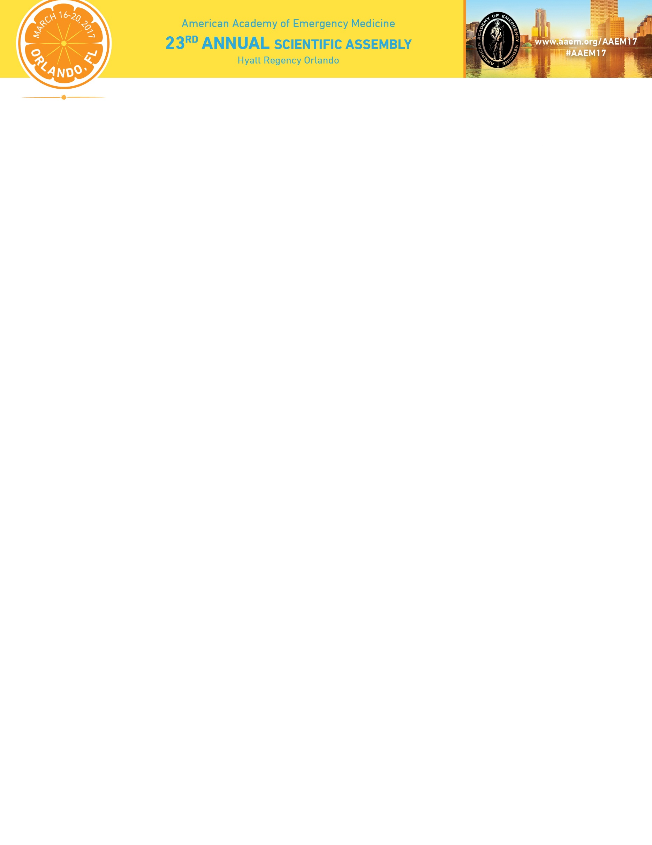

**Ultrasound Model Application Form**

I, _________________________________, verify that I have received and have read the

Print Name

Ultrasound Model instructions for the AAEM Ultrasound Course(s) that will be held on Thursday, March 16, 2017, between the hours of 12:30pm-4:30pm and Friday, March 17, between the hours of 7:30am-12:15pm at the Hyatt Regency Orlando, 9801 International Drive, Orlando, FL 32819.

I understand the instructions and agree to be one of the following models:

* Transabdominal, Neck and Cardiac

Email: __________________________________

Cell Phone #: ____________________________

_______________________________________

Signature

_____________________________________

Date

Please return

* completed Ultrasound Model Application form and
* W9

to Kathy Uy, AAEM Meetings Manager at kuy@aaem.org.